**Video Segmentation Challenge**

**DISCLAIMER: This article requires a basic understanding of neural networks**

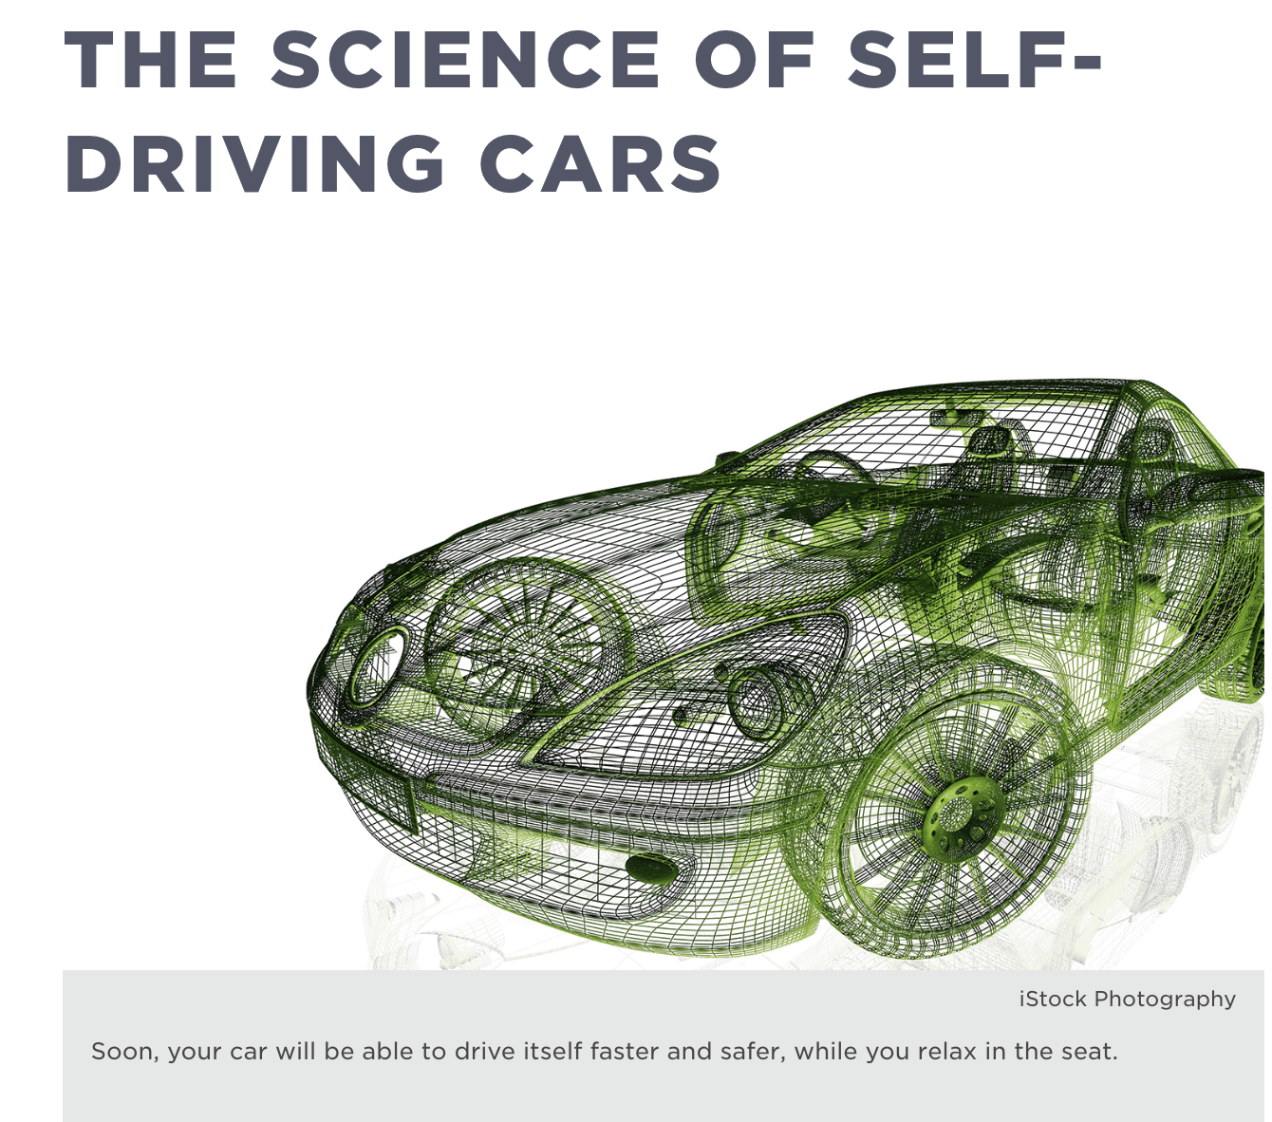

An increasing number of applications in today’s world are gathering information from images. One such application is self-driving cars and our team was very interested in understanding the problem of environmental perception for autonomous driving. So we did this for our term project. In this blog, we will take a look at algorithms which improve a car’s ‘perception’ using images from car cameras and our implementation of these algorithms.

As you can imagine, environmental perception is a pretty complex problem. In fact, it is one of the most difficult problems existing today. So, for such a complex problem, what do we use? Something even more complicated! We use neural networks to achieve high quality result, to be precise, we use DEEP LEARNING! Excited? Then waste no time and read further! If you are wondering where to get the data for developing and training neural networks for such a problem, look no further than Kaggle. A [Kaggle competition](https://www.kaggle.com/c/cvpr-2018-autonomous-driving) with around 96 GB image data from two car cameras with images containing different objects and pre-labeled classes is our savior. We use these abundant pre-labeled images (over 39,000) to train the network and around 1900 images to evaluate how accurately the network works.

Sample Training data:

Color training images Label training images

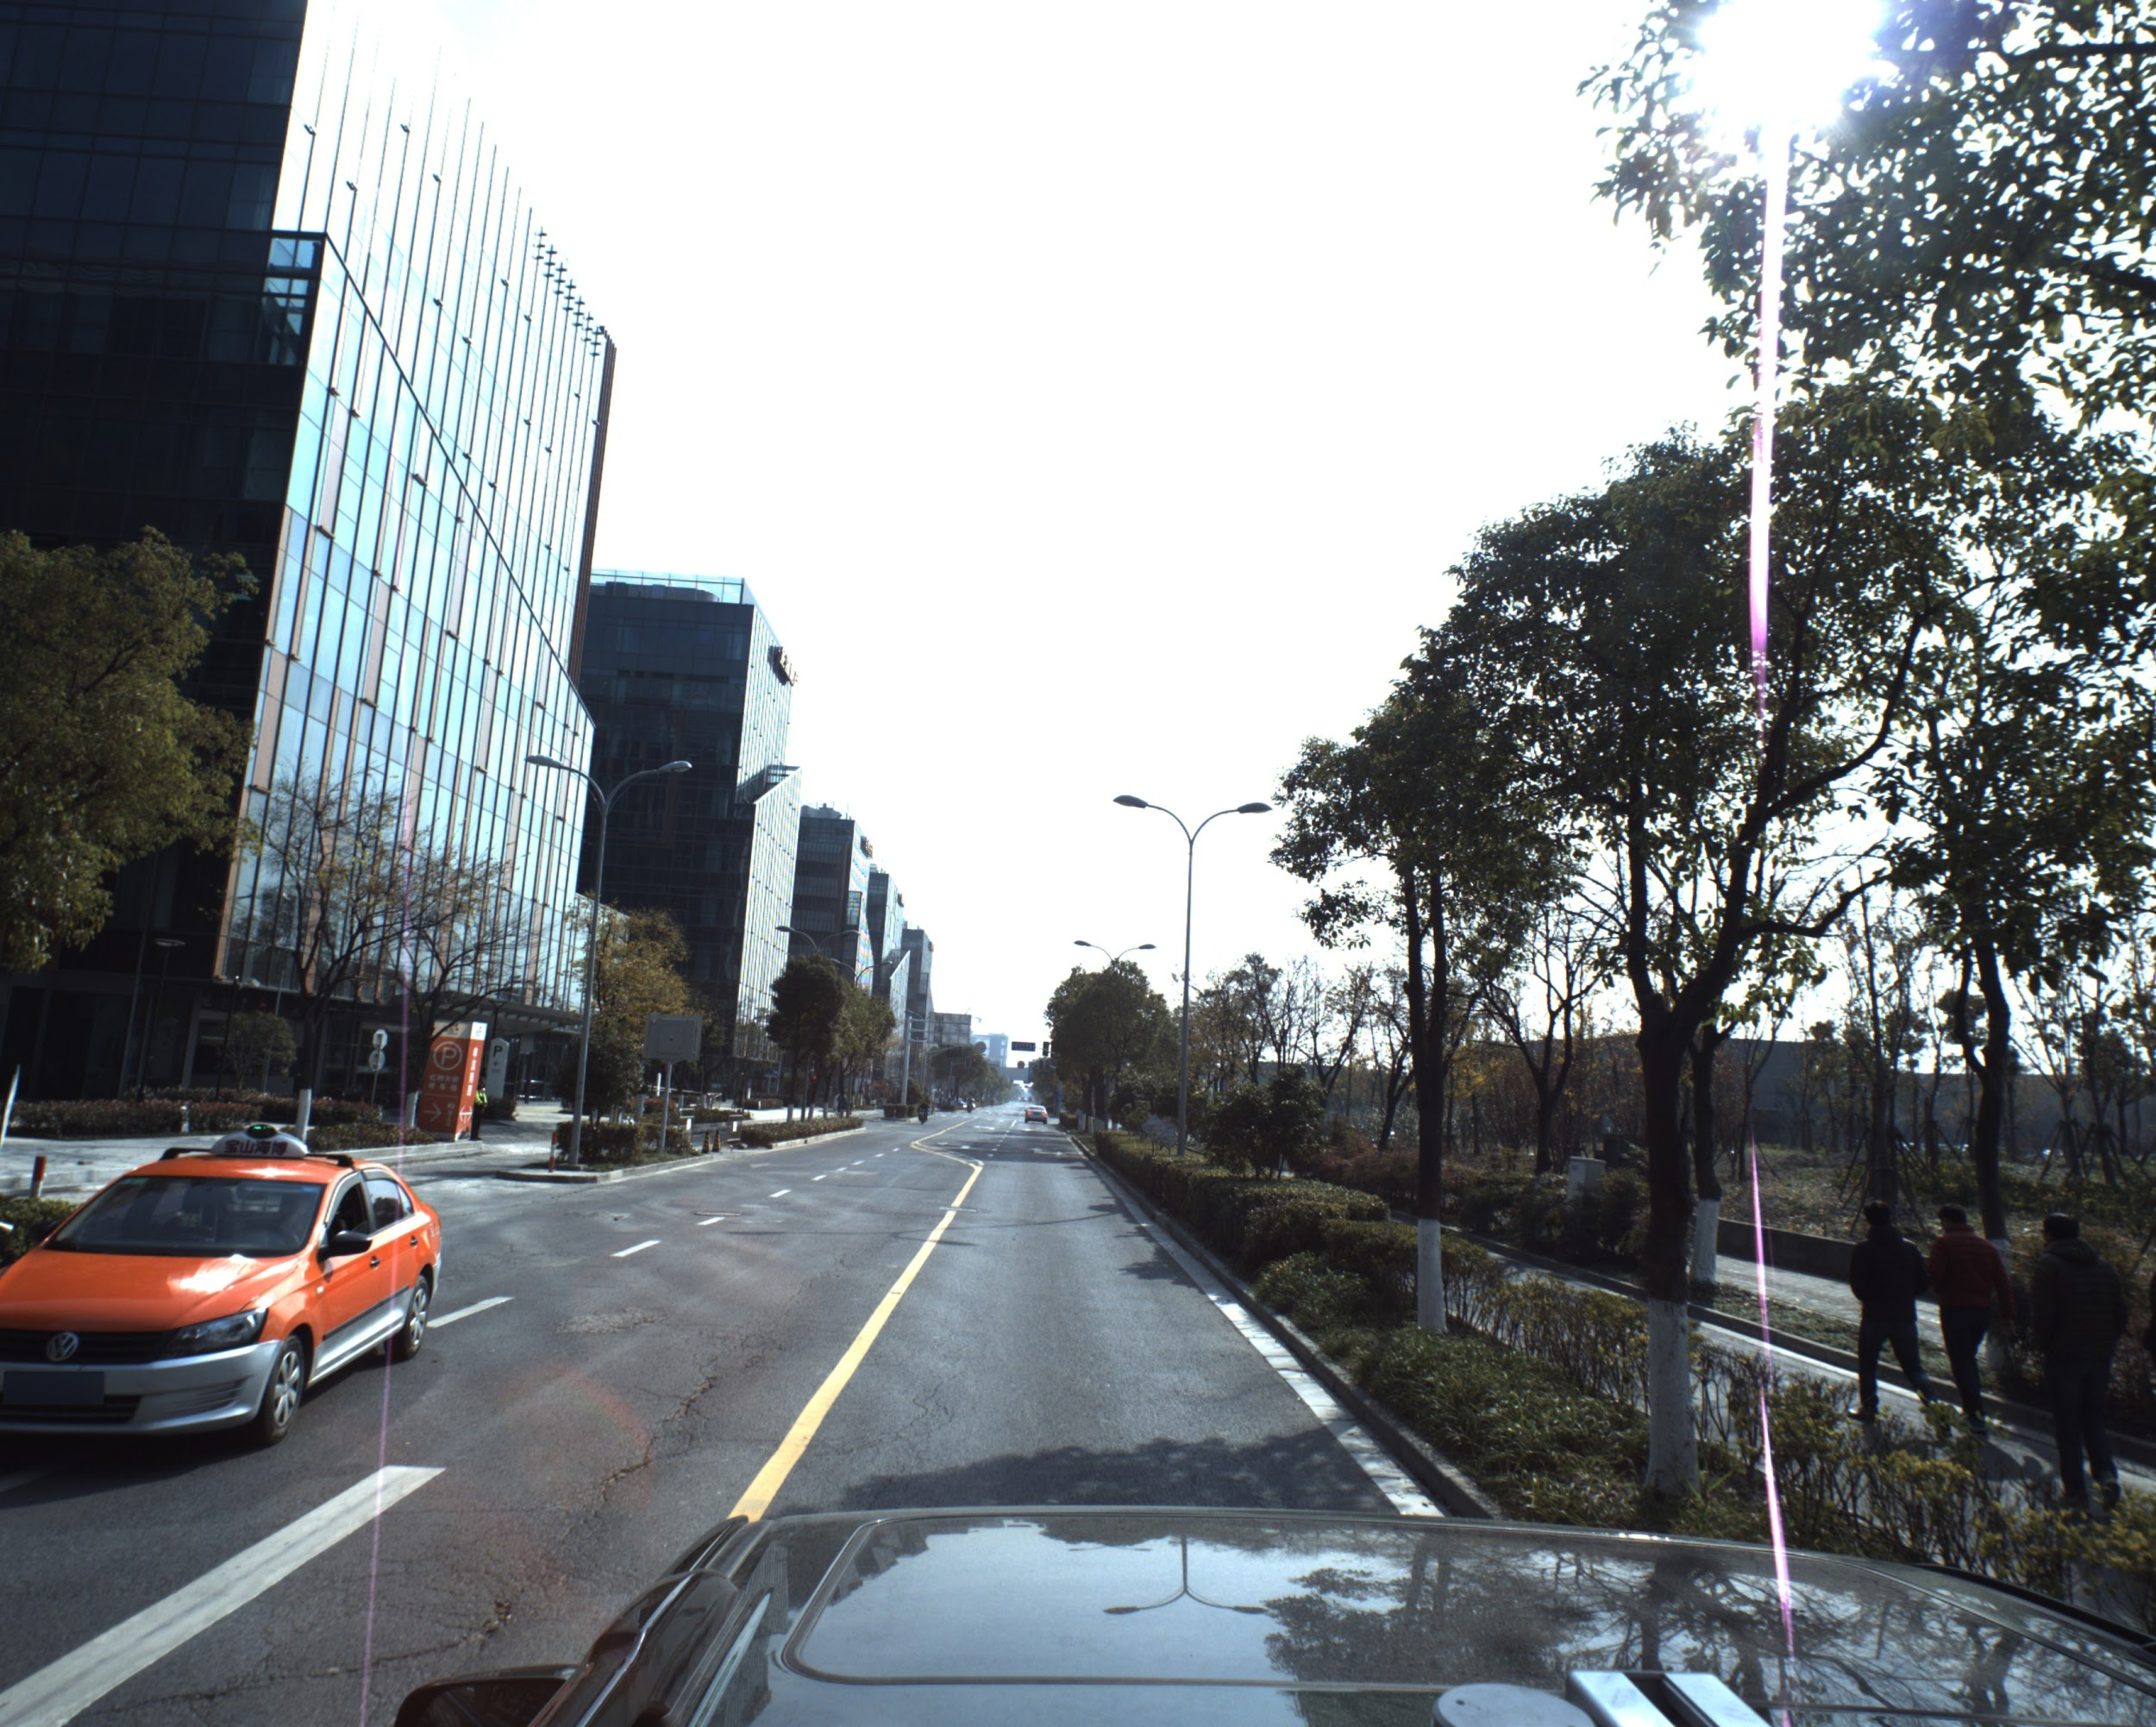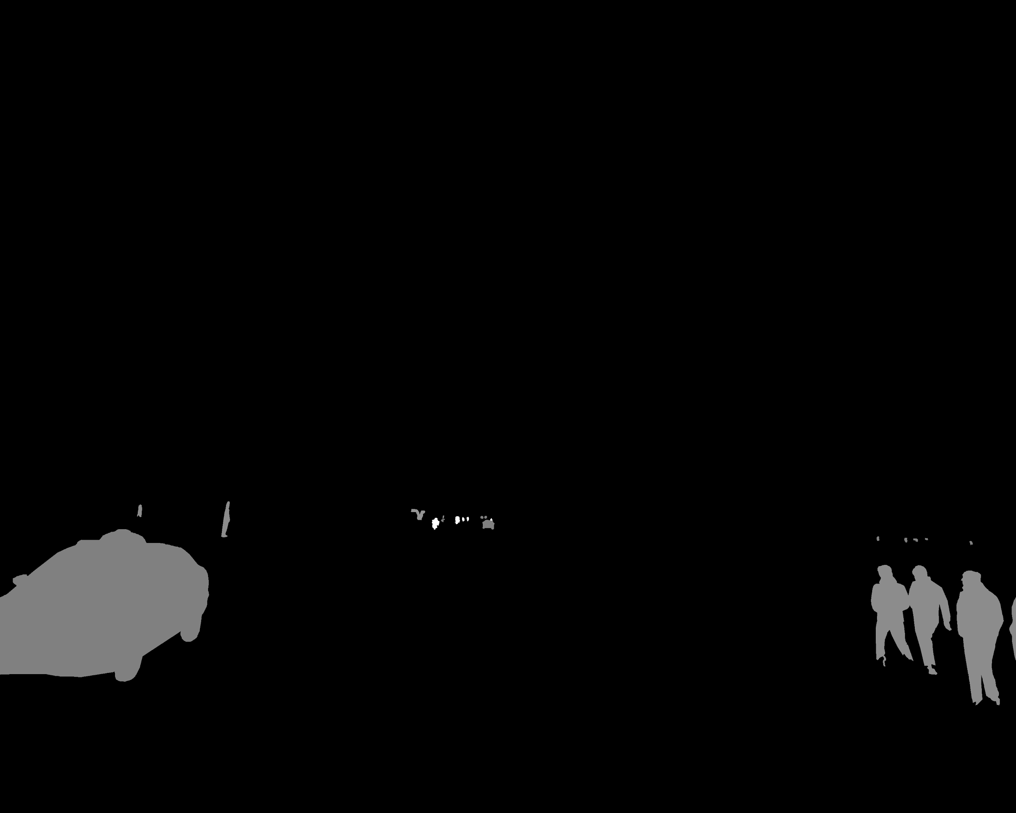

To start with, we performed some exploratory data analysis on the dataset. Using scikit-image segmentation module, dask, and matplotlib, we were able to display the original image and the colored labels.

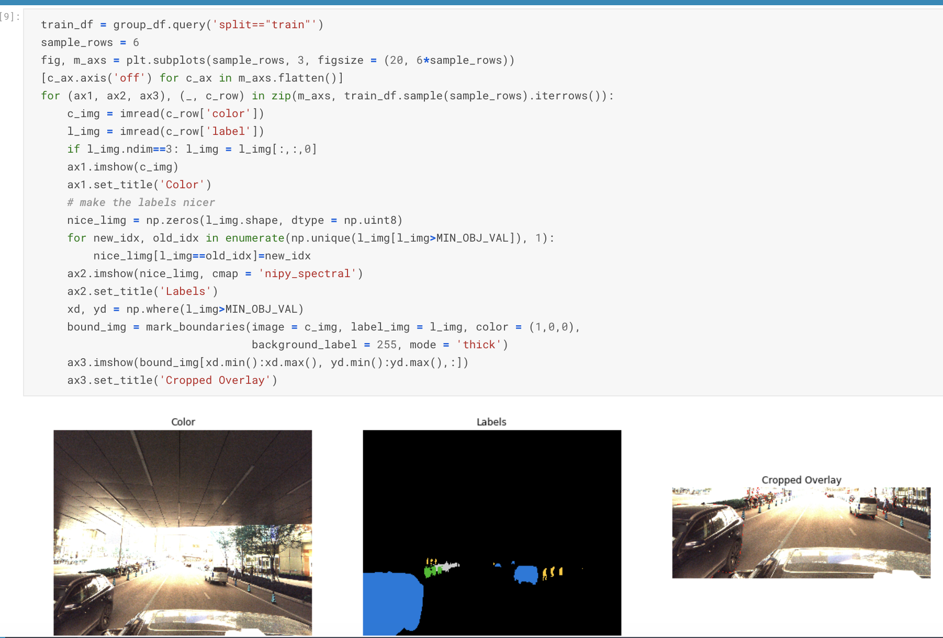

We also did a basic temperature check on the types of objects in our data. The below graphs show the results.

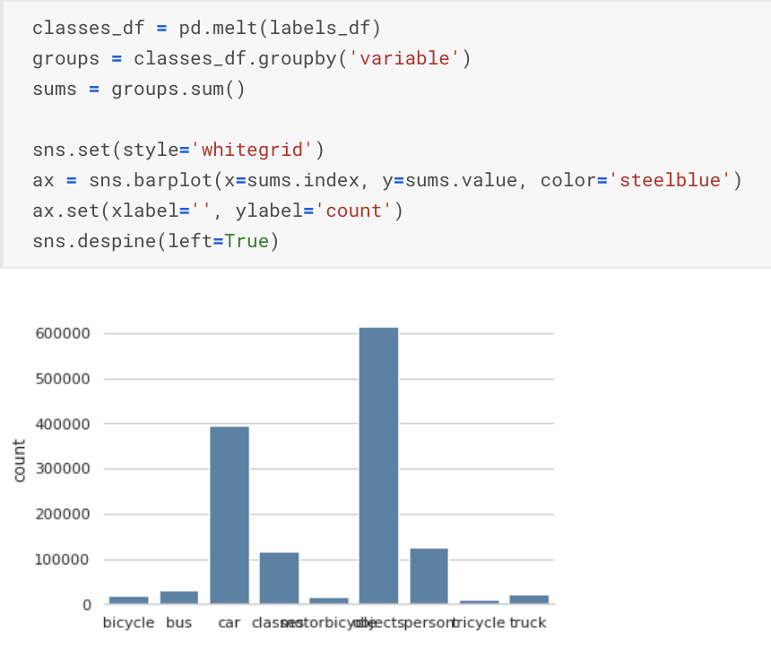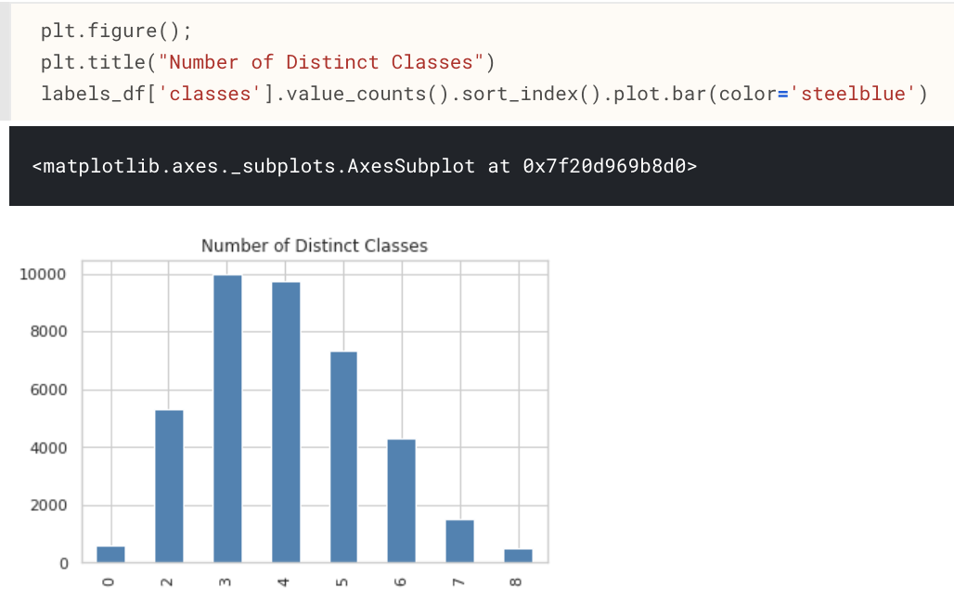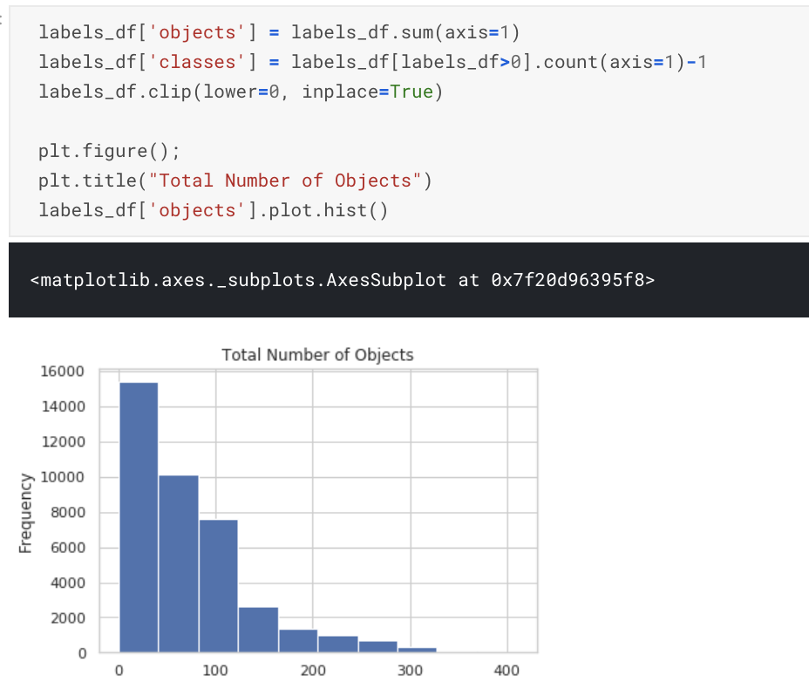

As expected most of the images have people and cars and most of the images have less than 50 objects with maximum images containing three object classes.

Now, let’s get a bit more technical.

In our problem, we are basically trying to perform scene understanding using semantic segmentation. Semantic segmentation is understanding an image at pixel level i.e, we want to assign each pixel in the image to a class. One of the key questions we had while beginning this project was how this was different from object detection. The idea of object detection revolves around finding an object of interest by drawing a bounding box around it. On a very basic level, it essentially divides the image into grids and passes the grid through convolutions. After multiple passes, we get a bounding box with an object inside it. Semantic segmentation takes object detection to a deeper level and performs a multi-class classification at the pixel level. Here, we force a pixel to have only one label.

This can be better seen through the below image:

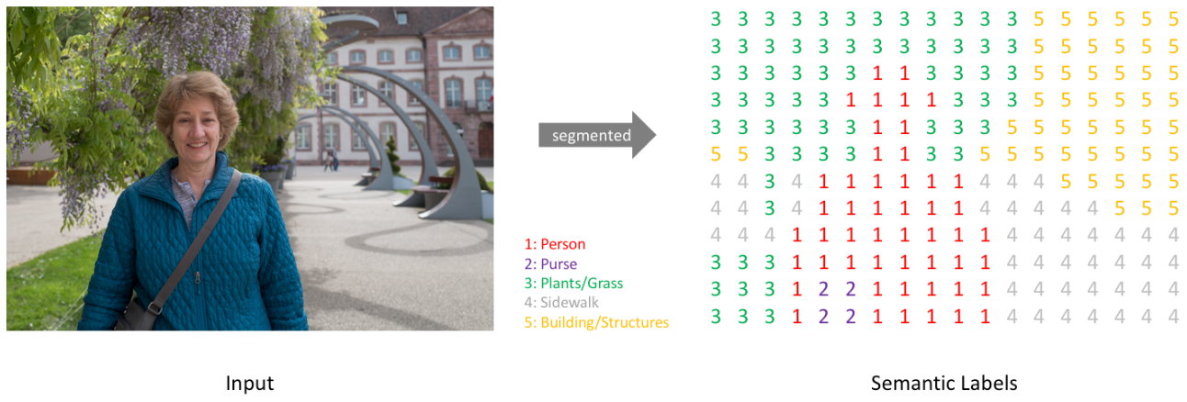

Semantic segmentation, apart from recognizing the woman and the tree behind her, also delineates the boundaries of each object in the above image. Hence, unlike classification, the models have dense pixel-wise predictions. These delineated boundaries from semantic segmentation are very relevant to autonomous vehicles as they help in perception through full scene understanding, which in turn helps in the vehicle to make decisions.

There are two types of semantic segmentations:

1. Pixel by pixel: performing multi-class classification at the pixel level (which we perform in this problem)
2. Instance segmentation: performing multi-class classification at pixel level and identifying instances of each class. For e.g., the model now sees two instances of pavement and two instances of vegetation.

Being such a popular and intriguing problem, many neural network architectures exist in the industry for semantic segmentation (the latest and greatest being PSPNet and DeepLab v3 by Google). For our implementation, we decided to use PSPNet as well as a more traditional model called UNet.

Having gained a deeper understanding of the problem, the next step is to figure out computation and storage of the data. The logical conclusion is to use the cloud. We had two options, Amazon Web Services (AWS) and Google Cloud Platform (GCP). We chose GCP because it has more free credits as well as the GPU can be easily accessed (GPUs are a must-have for deep learning problems). To bypass the time consuming process of installing GPU drivers, we created an image of these drivers using this amazing article by [Stanford Computer Vision class](http://cs231n.github.io/gce-tutorial/). However, this installs an older version of keras. To fix this and install the latest versions, we used the below commands:

*alias sudo='sudo env PATH=$PATH'*

*sudo pip install keras==2.2.4*

Along with this, the actual image sizes were giving us a problem too. As our dataset includes many high-resolution images, data pre processing took almost 50% of our time! We tried a couple of methods to reduce the image size and make the processing faster. The first method is very basic: we just reshaped the image to a lower resolution. In the second method, we thickened the boundary of the objects in the image by one pixel and provided this new boundary as input to the network. This created more segmented images and would help the network identify different objects better.

Now moving on to the algorithms. First, we tried **UNets:**

UNet is one of the most popular neural network models for pixel classification. This net came into existence with an application in biomedical segmentation. It is symmetric in shape and is basically a combination of multiple convolutional and max-pooling layers. The left side of the network is the contracting path or the encoder and is a standard classifier. This path captures information about what the object is as we move further down. The right side of the network is the expansion path or the decoder where we perform upsampling using up-convolutions. This is what basically gives our segmentation map.

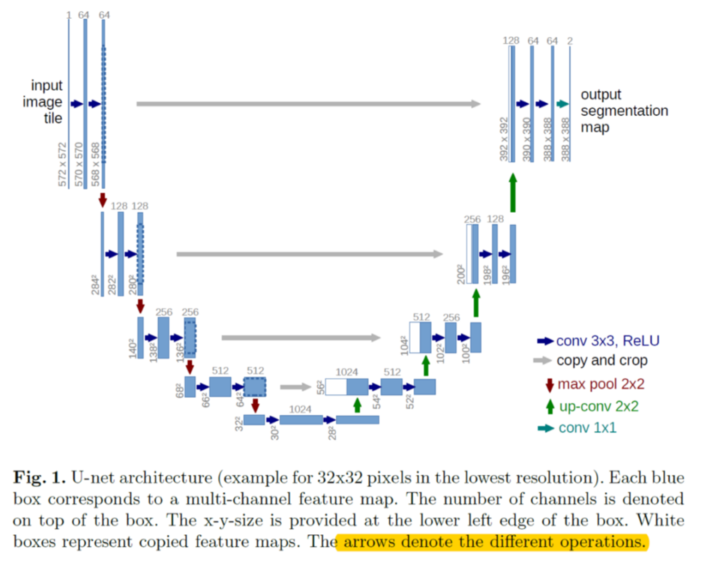

The most important parts of the network are the grey arrows feeding in from the encoder which give high-resolution information about the features or the objects. We chose this as one of our main models because it is **very good at detecting objects of the same class that are touching**. Since this model seems very good for our problem, let’s see how it fits on our data. We built two UNet models from scratch - one a typical UNet model (as you see above) and one a UNet model with a ResNet50 encoder (we will talk about this model later).

**Results for UNet**:

Below is the output of the UNet model that we built from scratch. We used Mean IoU (intersection over union) to evaluate our model. Mean IoU is a widely used metric for semantic segmentation problems. It basically measures the overlap between the target mask and our prediction output by taking the area of overlap and dividing the area of the union from both our predicted and true labels. The mean IoU for our model was about 0.49.

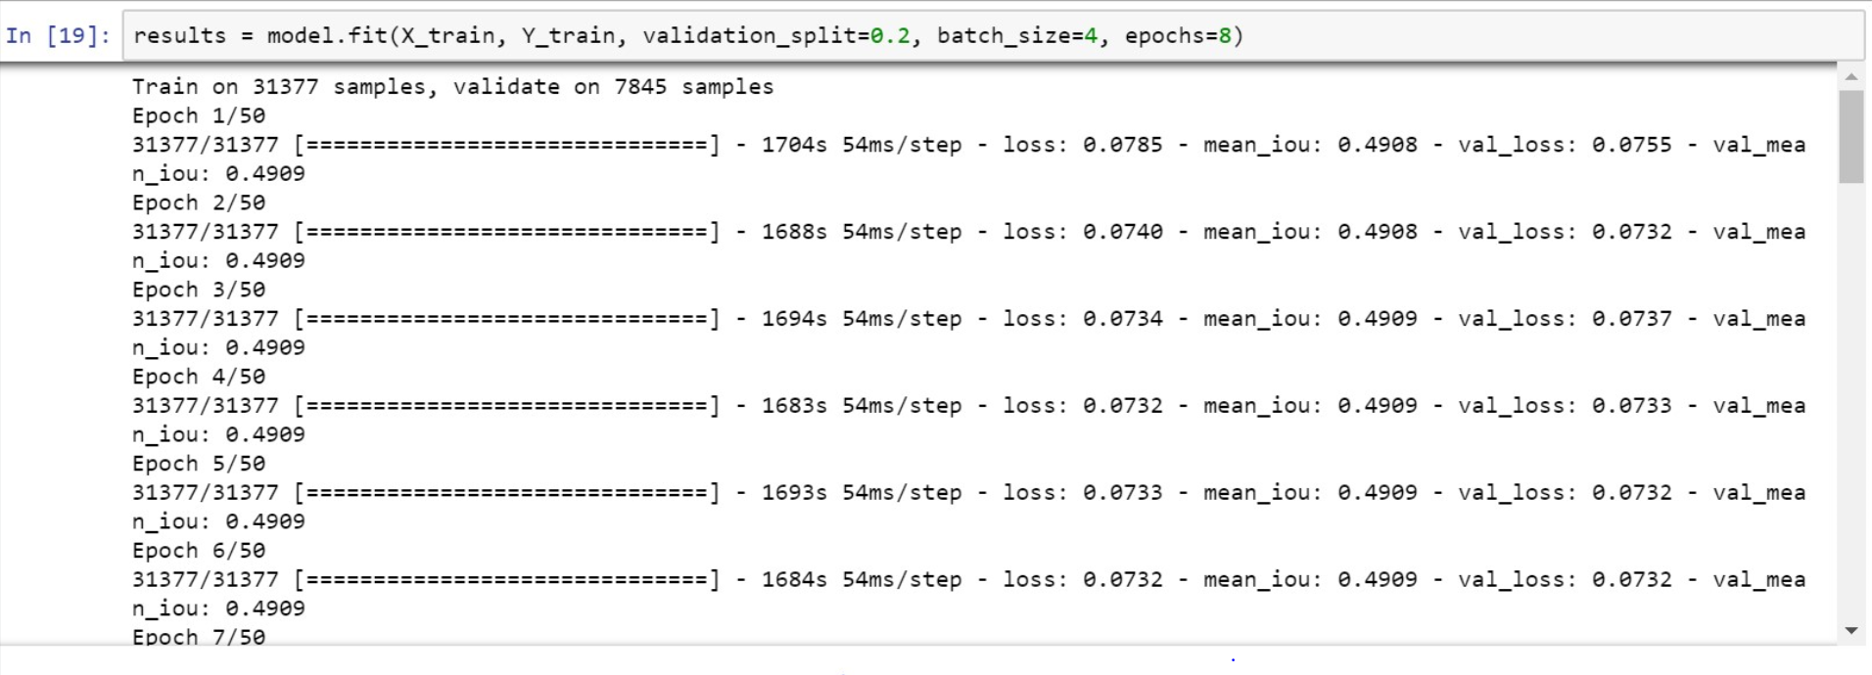

Let’s discuss a more cutting edge architecture, **PSPNet**:

Most of the semantic segmentation methods have similar architectures with an encoder network followed by a decoder, but very few take into consideration the context of the scene i.e. on the global priors. Global priors come in handy because they provide common sense to the scene. Information from global priors can correct the flaws of the other networks which often mistake objects that have similar spatial features (boat vs car), belong to confusion categories (building vs skyscraper, wall vs house, pole vs traffic signal), or have similar matching backgrounds. This is incorporated by PSPNet which uses FCN plus Average Pooling for classification and Spatial Pyramid Matching for scene understanding.

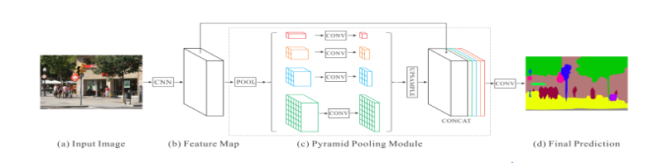

PSPNet’s first step i.e. feature map is obtained from a pretrained ResNet model and the pyramid levels on top of this map are built to separate it into different sub-regions and form pooled representation for different locations. These 4-level pyramid poolings cover the whole, half, and small portions of the image for different locations. Then, we upsample the low-dimension feature map to the same size as the original feature map via bilinear interpolation method. The scaled features are then added back to the original feature map and final predictions are made.

**Results for PSPNet:**

In our project, we used the weights from a pre-trained PSPNet obtained from similar driving images dataset called Cityscapes. As this model is known to be quite robust, we tested it on a couple of our images and the accuracy was coming out to be great. Currently, we are in the process of implementing transfer learning but because this model is new and not yet integrated with Keras application, we ran into many issues as discussed later in our challenges. But as of now, with the current model, we are getting an accuracy of over 90% in all cases.

**Results Overview**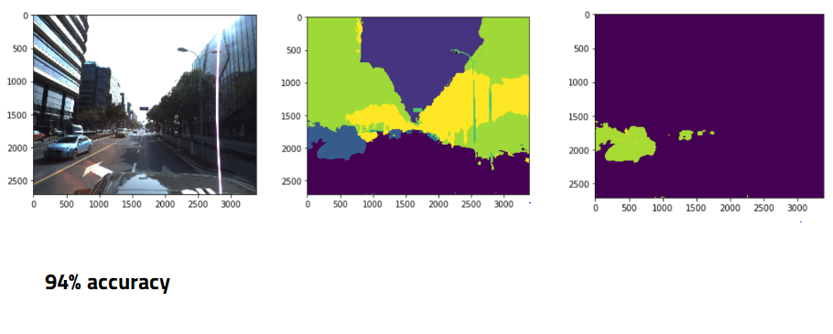  
As seen above, we see the different results given from both PSPNet: >90% accuracy, and UNet: 49% MIoU. So this means that PSPNet is better right?   
Unfortunately, we don’t know for sure. It is difficult to compare models based on different loss functions. That brings up the question, “Why can’t we use the same loss functions on both?”. We are quite sure that you could, however, it would require a much deeper and stronger understanding of semantic segmentation as well as of PSPNet. But from this project, we get a better understanding of how various models perform semantic segmentation and the difficulties that arise in image segmentation problems. This brings us to our first of many challenges that we faced during this project:

**CHALLENGE 1: Starting with pixel-by-pixel segmentation for self-driving cars is like playing FIFA on Legendary mode when you don’t even know what soccer is**

We chose semantic segmentation for self-driving cars because it seemed like a very relevant and hot topic (and honestly, it would be amazing to have on our resume), however, we didn’t know how difficult such a task would be nor did we have any prior experience with image segmentation. Throughout this process, we found very few resources online to help us understand the basics of how to go about this specific problem. We scraped the internet for days to find every inch of information and code we could for this topic such as from GitHub and Kaggle. For each resource, in order to get even an inkling of what was going on, we had to run through it together line by line, code snippet by code snippet. So we highly recommend starting at the beginner level and moving up.

**CHALLENGE 2: Unable to replicate ANY already established results from given scripts and code.**

As we ran each of the resources we found, we met with a very confusing issue of not being able to get ANY results that we were supposed to. When we were supposed to get predictions for a PSPNet test set image, we would only get a black screen no matter how much we trained the model; when we tried to train a UNet model, it would train all 70GB of data in 5 minutes and give us a loss of 0% (which is obviously wrong unless we are actually geniuses). Because of these faults, we just decided to take one pre-trained model (PSPNet) and see if we could perform transfer learning based on our own knowledge, as well as develop a UNet model from scratch.

**CHALLENGE 3: “Wait, wait, wait… PSPNet is not in Keras????? How are we supposed to do anything?!”**

PSPNet is not integrated with Keras. Keras has built-in functions that allows one to access layers of the neural net, freeze and change certain weights, and perform transfer learning with a few lines of code. In our situation, we weren’t even able to open the weights of the net, let alone change them. In order to change the layers manually, we went deep into the supporting python scripts which defined the model and each convolution layer, but, unfortunately, had little luck. Along with this, it was no longer straightforward to perform loss functions on our outputs, which are also native to the Keras integration for other models. Thus, we had to code up our own loss function and manually perform pixel-by-pixel accuracy for our images.

Throughout the entire process, we met with a large number of hurdles: some we were able to jump over, and some we got our foot tangled in at the top, but we never gave up. Because we never gave up, we learned so much more than we would’ve had our models worked on the first go. Here are our key takeaways that we believe will save you from destroying your laptop out of frustration:  
 **1. Start from the Basics**  
Looking back now, the way we approached our problem was slightly flawed. Instead of working with our dataset and building a model on top of that, we started with a model, and went backwards to understand the dataset and what we were doing. It would’ve been smarter for us to take on an object detection problem and then try and integrate pixel-by-pixel segmentation once we got a hang of how image detection works and what it needed to succeed.  
 **2. Learn how to use Google Cloud Platform or any cloud platform**   
GCP became our lifesaver when we had to deal with the over 90GB of data for this problem. Our laptops couldn’t even handle 10GB of it. So, be safe than sorry and be sure to have more storage and RAM than you need so 48 hours aren’t wasted in running a code that ends up saying “Memory Error”.

**3. Advanced models are not always suitable for every problem**

PSPNet will give great results when the scene is complex and the images have high number of diverse objects. When number of categories are less like in the above case of self-driving cars, where you can only see so many objects on the road, this architecture might provide redundant information.

We would like to caveat this by saying the expensive computations would be worth the efforts in real life. For example, we would rather have the car identify a person or a truck than not identify it correctly. However, as a class project, the computational effort may not lead to a significant increase in accuracy and thus, the trade-off becomes difficult to balance.

On that note, we became so invested in this project and want it to be successful that we created a task-list of what future steps are needed. First off, we want to continue to focus on the from-scratch UNet model. As we have the most control over this model, our goal is to increase the mean IoU of this model. Next, we want to figure out how to fully implement transfer learning in our PSPNet model. This will require us to spend a lot more time understanding the small nuances involved with the model and find out exactly how to access the weights. Lastly, if we are successful in our previous two tasks, we want to implement this project with DeepLab version 3- the newest and hottest semantic segmentation model implementation for self-driving cars yet. This is something that has not yet been done with our current dataset and we expect great results if we are successful with it.

Link to code

FOOTNOTES:

In other networks, these misclassifications are majorly because all output neurons are connected to all input neurons. This logic falls short for segmentation if you are working in a huge space of possibilities (unconstrained number of classes in case of real images) because same activations may not be sufficient to correctly predict the segmentation.

Mean IoU is a widely used metric for semantic segmentation problems. IoU stands for intersection over union. It basically measures the overlap between the target mask and our prediction output by taking the area of overlap and dividing the area of the union from both our predicted and true labels. The IoU is then aggregated over all the images to give Mean IoU. When using Mean IoU, we can control for the total number of pixels for a class. Accuracy can be misleading in semantic segmentation problems. For example, the majority of pixels might be a background so if a model is able to predict all background, it will have seemingly good performance. As a ratio, IoU is less susceptible to this.

Thoughts:

In the process of learning, we realised that PSP could be good when the scene is complex and the dataset has higher number of diverse objects. When number of categories are less like in case of self-driving car recorded scenes, this architecture might provide redundant information. Now, this might provide better pixel accuracy but the computational cost of training huge number of parameters involved in 3*3 convolutions in the pyramid pooling module is probably not worth it.

**3. NEVER source your data or ideas from Kevin Mader on Kaggle**  
Most of the kernels on our Kaggle competition are provided with Kevin, however, NONE of them fully work. So much of our time was wasted in believing his code was 100% functional and the issue was on our end. Do yourself a favor and delete him from your life because there is only pain down that road.

EXTRAS

The prefixes of the training data files represent dates the pictures were taken. It also includes frame numbers and the number of camera. Training labels are generated from training data files by encoding the data in a format that mixes spatial and label/instance information. Pixel values indicate both the label and the instance. int(PixelValue / 1000) is the label of class of object and PixelValue % 1000 is the instance id.

**EDA on Training Data:**

To begin with, we would like to see what the training images look like and what we are suppose to detect. 

*The competition provided us images, but the raw data were videos. Therefore, we recovered few images to videos for fun using matplotlib’s animation module.*

Then, we were interested in analyzing the classes in the training dataset as we were hoping to gain some insights from the classes’ distributions.

We first created a dataframe called label_df, which contains the label file name and number of interested classes in each training label image.

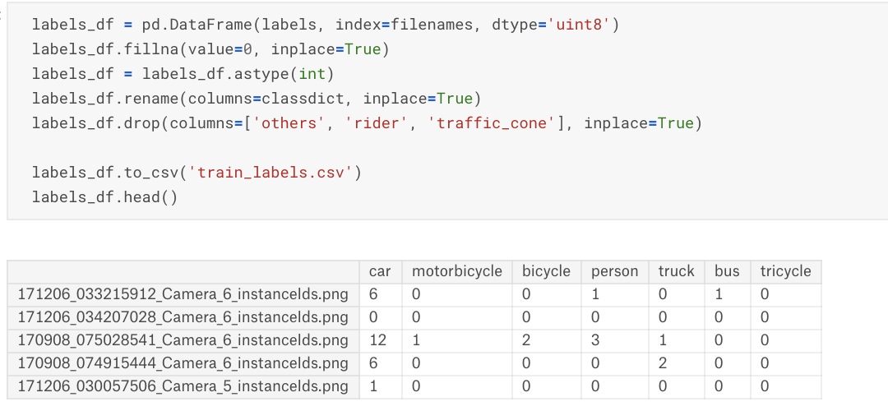

Using the data frame above, we created few histograms using seaborn library.

**Class Frequencies:** We found that cars and person are the two most frequently appeared classes in image.

**Number of Cars per Image:** Majority of the images have 0~10 cars.

**Number of Person per Image:** Most of the images have 0~5 people.

**Total Number of Classes per Image:** Most of the images have 0~30 classes.

**Number of Distinct Classes per Image:** The majority of images have two to four distinct classes.

|  |  |
| --- | --- |
|  |  |
|  |  |
|  |  |

Setting up the infrastructure: GCP Installation, challenges? Creating an instance, looking for proper documentation , request to increase the limit of global quota. Pushing the entire data on storage to instance. Setting up the libraries and jupyter notebook.

Alternate steps that could have saved time:

Direct API that linkes kaggle and GCP.

Direct uploads to instance rather than uploading to storage and from there to instance.

Finding the right documentation and directly starting off by using an image provided by Stanford course which has all the modules already loaded.

**Methods:**

In our problem, we are basically trying to perform scene understanding using semantic segmentation. Semantic segmentation is understanding an image at pixel level i.e, we want to assign each pixel in the image to a class. One of the key questions we had while beginning this project was how is this different from object detection. The idea of object detection revolves around finding an object of interest by drawing a bounding box around it. On a very basic level, we essentially divide the image into grids and pass the grid through convolutions. After multiple passes, we get a bounding box with an object inside it. Semantic segmentation is taking object detection deeper and performing a multiclass classification at the pixel level. Here, we force a pixel to have only one label.

This can be better seen through the below image:



Semantic segmentation, apart from recognizing the woman and the tree behind her also delineates the boundaries of each object in the above image. Hence, unlike classification, the models have dense pixel-wise predictions. These delineated boundaries from semantic segmentation are very relevant to autonomous vehicles as they help in perception through full scene understanding, which in turn helps in the vehicle to make decisions.

There are two types of semantic segmentation:

1. Pixel by pixel: performing multiclass classification at the pixel level
2. Instance segmentation: this entails performing multiclass classification at pixel level and identifying instances of the class. For e.g., the model now sees two instances of pavement and two instances of vegetation.

In this particular problem, we are performing pixel by pixel segmentation.

These are many neural network models that are used in the industry for semantic segmentation.

Current trends in semantic segmentation: May be a line or two and some best architectures

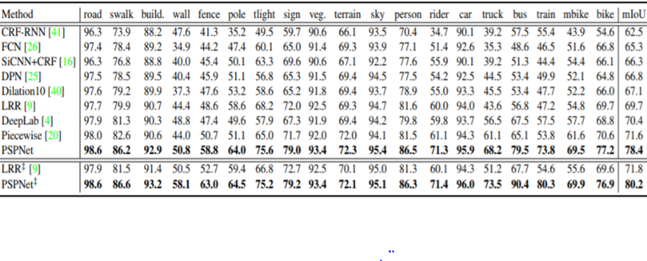

We used UNet and PSP Net which are discussed below:

**UNETS:**

UNet is one of the most popular neural networks for pixel classification. This net came into existence with an application in biomedical segmentation. It is symmetric in shape and is basically a combination of multiple convolutional and max-pooling layers. The left side of the network is the contracting path or the encoder and is a standard classifier. This path captures information about what the object is as we move further down. The right side of the network in the expansion path or the decoder where we perform upsampling using up-convolutions. This is what basically gives our segmentation map



The most important part of the network is the grey arrows feeding in from the encoder which give high-resolution information about the features or the objects. We chose this as one of our main models because it is very good at detecting touching objects with the same class. Since this model seems very good for our problem, let’s see how it fits on our data. We built two UNet models from scratch - one a typical UNet model (as you see above) and one a UNet model with a ResNet50 encoder (we will talk about this model later).

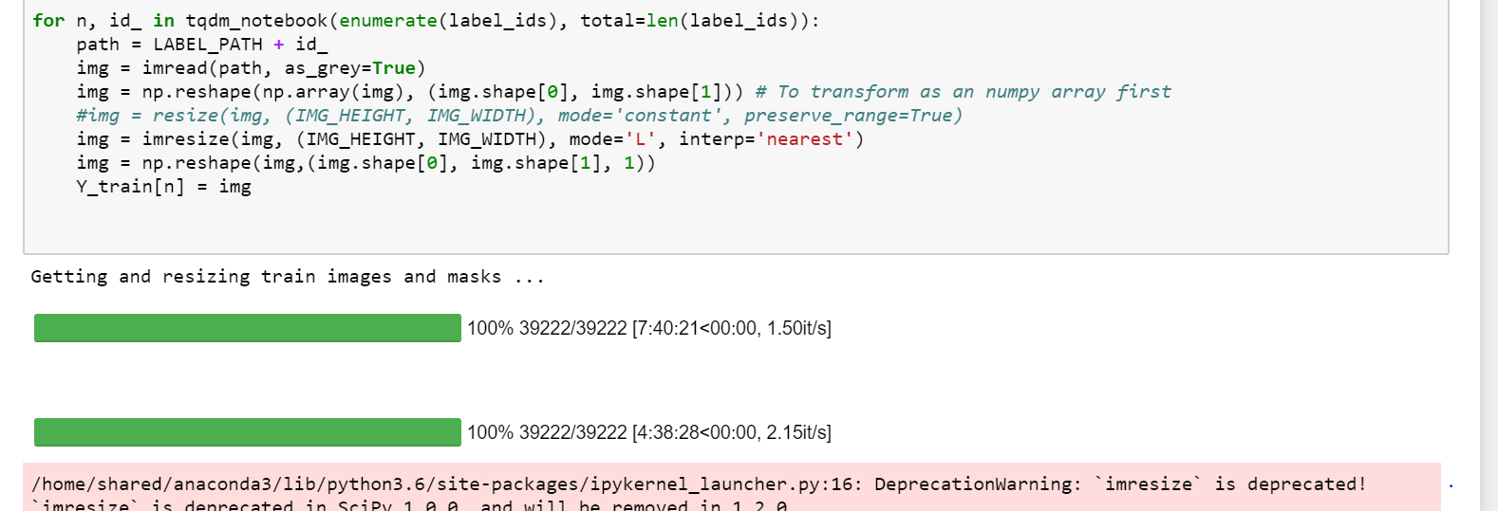

The major issue with any image problem is the size. Our dataset included many high-resolution images. So data pre-processing took almost 50% of our time of running the model. The above is just a basic pre-processing that we tried, where we are just reshaping the image to a lower resolution. Some other forms of pre-processing are:



This is the output of the UNet model that we built from scratch. We used Mean IoU to evaluate our model. Mean IoU is a widely used metric for semantic segmentation problems. IoU stands for intersection over union. It basically measures the overlap between the target mask and our prediction output by taking the area of overlap and dividing the area of the union from both our predicted and true labels. The IoU is then aggregated over all the images to give Mean IoU. When using Mean IoU, we can control for the total number of pixels for a class. Accuracy can be misleading in semantic segmentation problems. For example, the majority of pixels might be a background so if a model is able to predict all background, it will have seemingly good performance. As a ratio, IoU is less susceptible to this. The mean IoU for our model was about 0.49.

WHERE TO INCLUDE THIS?

We tried another unet model from scratch where we used a resnet as an encoder. ResNet is a very deep model with 152 layers and uses skip connections. These skip connections are very important because they help us in preserving spatial information which as you can imagine is very important in scene understanding. For this model, we just used binary cross entropy to calculate the loss between the predicted and the truth. Now Apoorva is going to talk about the other net that we used PSPNet.

PSPNet

Most of the pixel wise (semantic) segmentation methods have a similar architecture with an encoder network followed by a decoder. Encoder is usually a pre trained classification network while the decoder projects the lower resolution discriminative features obtained from the encoder onto the higher resolution pixel level. Very few have talked about the context of the scene i.e. on the global priors.

Now, the concept of global priors comes in handy because it provides common sense to the scene. Information from global priors can correct the flaws of the other networks which often mistake objects that have similar spatial features (boat vs car) or belong to confusion categories (building vs skyscraper, wall vs house, pole vs traffic signal) or similar matching backgrounds. In other networks, these misclassifications are majorly because all output neurons are connected to all input neurons. This logic falls short for segmentation if you are working in a huge space of possibilities (unconstrained number of classes in case of real images) because same activations may not be sufficient to correctly predict the segmentation.

Network Architecture:

PSPNet provides a superior framework for pixel-level prediction by incorporating two things:

* State-of-the-art Image classification uses FCN + Average Pooling
* Classical scene understanding uses Spatial Pyramid Matching



PSPNet’s first step i.e. feature map is obtained from a pretrained ResNet model and the pyramid levels on top of this map are built that separates it into different sub-regions and forms pooled representation for different locations. These 4-level pyramid poolings cover the whole, half of, and small portions of the image for different locations. Then we upsample the low-dimension feature maps to the same size as the original feature map via bilinear interpolation method. The scaled features are then added back to the original feature map and final predictions are made.

Implementation:

Coming to the implementation part, we basically used the weights from the PSPNet obtained from similar driving images dataset called Cityscapes on which it was giving a good accuracy and tested it on couple of our images and the accuracy was coming out to be great. Currently, we are in the process of implementing transfer learning but because this model is new and not yet integrated with Keras application, the usually inbuilt functions to access checkpoints and weights, accuracy calculations are not that straight forward in our case so we tested out couple of images and it was giving us an accuracy of greater than 90% percent in all the cases.



Thoughts:

In the process of learning, we realised that PSP could be good when the scene is complex and the dataset has higher number of diverse objects. When number of categories are less like in case of self-driving car recorded scenes, this architecture might provide redundant information. Now, this might provide better pixel accuracy but the computational cost of training huge number of parameters involved in 3*3 convolutions in the pyramid pooling module is probably not worth it.

**Results Overview:**

As talked about before, we see the different results given from both PSPNet: 94% accuracy and UNet: 49% MIoU. So this means that UNet is better right?   
Unfortunately, we don’t know for sure. It is difficult to compare models based on different loss functions. That brings up the question, “Why can’t we use the same loss functions on both?”. We are quite sure that you could, however, it would require a much deeper and stronger understanding of semantic segmentation as well as of PSPNet which we do not have as of now. But from this project, we get a better understanding of which models would be more effective in certain environments. For example, we concluded that the pre-trained version of PSPNet tends to overfit our Kaggle competition problem. In the real world for self-driving cars, this may be better than underfitting (which happens through UNet), as it would be safer to have more false positives of a car, truck, or pedestrian than false negatives. This brings us to our first of many challenges that we faced during this project:  
**CHALLENGE 1: starting with pixel-by-Pixel segmentation for self-driving cars is like playing FIFA on Legendary mode when you don’t even know what soccer is**We chose semantic segmentation for self-driving cars because it seemed like a very relevant and hot topic (and honestly, it would like amazing to have on our resume), however, we didn’t know how difficult such a task would be. Throughout this process, not only did we realize that we were highly underqualified to take on such a problem, we also found very few resources online to help us understand the basics of how to go about this problem. But we don’t back down from a challenge. We scraped the internet for days and tried to find every inch of information and code we could for this topic such as from GitHub and Kaggle. For each resource, we ran through it together, line by line, code snippet by code snippet, and truly got to understand what the model was doing and how it was doing it on a fundamental level.  
**CHALLENGE 2: Unable to replicate ANY already established results from given scripts and code.**As we ran each of the resources we found, we met with a very confusing issue of not being able to get ANY results that we were supposed to. When we were supposed to get predictions for a PSPNet test set image, we would only get a black screen no matter how much we trained the model; when we tried to train a UNet model, it would train all 70GB of data in 5 minutes and give us a loss of 0% (which is obviously wrong unless we are actually geniuses); when we tried to just output a scaled version of a trained image, it would show a blank image instead. Because of these faults, we just decided to take one pre-trained model (PSPNet) and see if we could perform transfer learning based on our own knowledge, as well as develop a UNet model from scratch.   
**CHALLENGE 3: “Wait, wait, wait… PSPNet is not in Keras????? How are we supposed to do anything?!”**PSPNet is not integrated with Keras. We will repeat that again, PSPNet is NOT integrated with Keras. Thus, given our dearth of knowledge on this subject, we were doomed from the start. Keras has built-in functions that allows one to access layers of the neural net, freeze and change certain weights, and perform transfer learning with a few lines of code. In our situation, we weren’t even able to open the weights of the net let alone change them. In order to change the layers manually, we went deep into the supporting python scripts which defined the model and each convolution layer, but no luck. Along with this, it was no longer straightforward to perform loss functions on our output that are also native to the Keras integration for other models. Thus, we had to code up our own loss function and manually perform pixel-by-pixel accuracy for our images.   
Throughout the entire process, we met with a large number of hurdles: some we were able to jump over, and some we got our foot tangled in at the top, but we never gave up. Because we never gave up, we learned so much more than we would’ve had our models worked on the first go. Here are our key takeaways that we believe will save you from destroying your laptop out of frustration:  
 **1. Start from the basics**  
Looking back now, the way we approached our problem was slightly flawed. Instead of working with our dataset and building a model on top of that, we started with a model, and went backwards to understand the dataset and what we were doing. It would’ve been smarter for us to take on an object detection problem and then try and integrate pixel-by-pixel segmentation once we got a hang of how image detection works and what it needed to succeed. Because we didn’t even know what to look for in our code or in our model to see if it works properly or not, it became a game of trial and error which is both confusing and a giant time waster.  
 **2. Learn how to use Google Cloud Platform or any cloud platform**   
GCP became our lifesaver when we had to deal with the over 90GB of data for this problem. Our laptops couldn’t even handle 10GB of it. There is a document (document is attached to blog) which we followed that helped us tremendously in using GCP to run and test our code However, even GCP wasn’t enough for us sometimes. Due to the size and computationally intensive characteristic of our data, GCP would have memory errors and such and we had to continue to ask for more GPUs and CPUs. So, be safe than sorry and be sure to have more storage and RAM than you need so 48 hours aren’t wasted in running a code that ends up saying “Memory Error”.

**3. NEVER source your data or ideas from Kevin Mader on Kaggle**  
Most of the kernels on our Kaggle competition are provided with Kevin, however, NONE of them fully work. So much of our time was wasted in believing his code was 100% functional and the issue was on our end. Do yourself a favor and delete him from your life because there is only pain down that road.

On that note, we became so invested in this project and want it to be successful that we created a task-list of what future steps are needed. First off, we want to continue to focus on the from scratch UNet model. We have the most control over this model is the most genuine representation of our work. Our goal is to increase the mean IoU of this model and perform it over the entire 70ish GB of training data. Next, we want to figure out how to fully implement transfer learning in our PSPNet model. This will require us to spend a lot more time understanding the small nuances involved with the model and find out exactly how to access the weights. Lastly, if we are successful in our previous two tasks, we want to implement this project with DeepLab version 3- the newest and hottest model implementation for self-driving cars yet. This is something that has not yet been done with our current dataset and could be groundbreaking if we are successful with it.

